**Practical Activity 10**

**Forensics Room in TryHackMe**



**Name:**Lamis Mohamed GabAllah

**Email :** [lamis.mohammed@womentechsters.org](mailto:lamis.mohammed@womentechsters.org)

**Date:** 7th August 2021

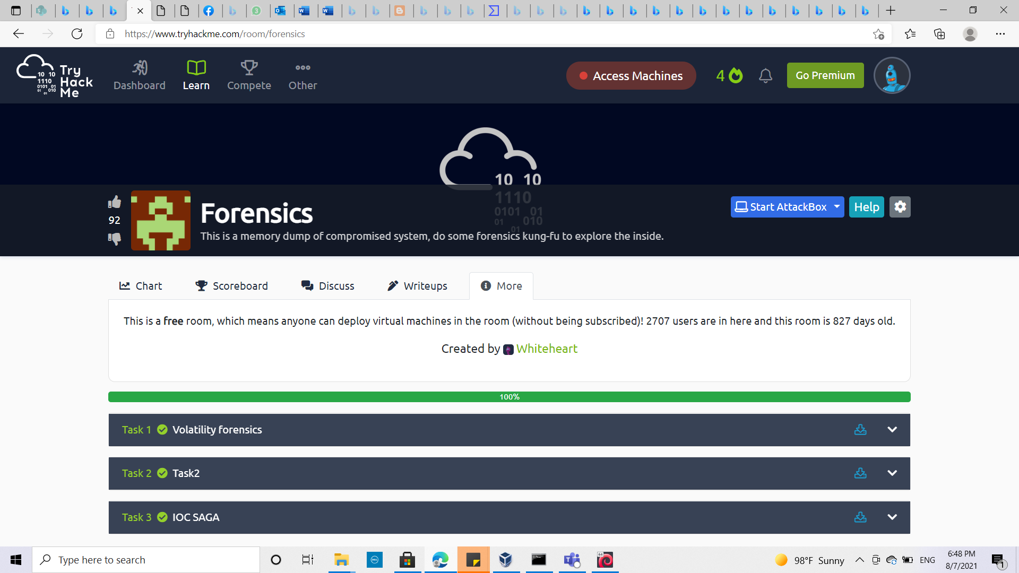

**Task 1 Volatility forensics**

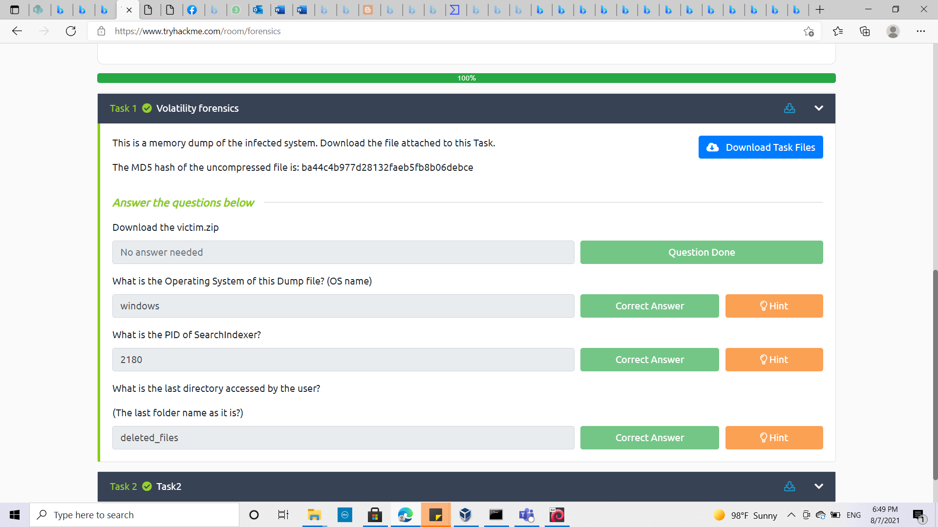**Q1:** Download the victim.zip   
victim.zip downloaded (memory dump file of the infected system that will be used for answering the other questions): Done

**Q2:** What is the Operating System of this Dump file? (OS name)  
 (answer: Windows)  
  
by using the plugin **imageinfo ,** check the suggested prortfolios as shown in the screenshot below

***Command used :*** volatility_2.6_win64_standalone -f victim.raw imageinfo

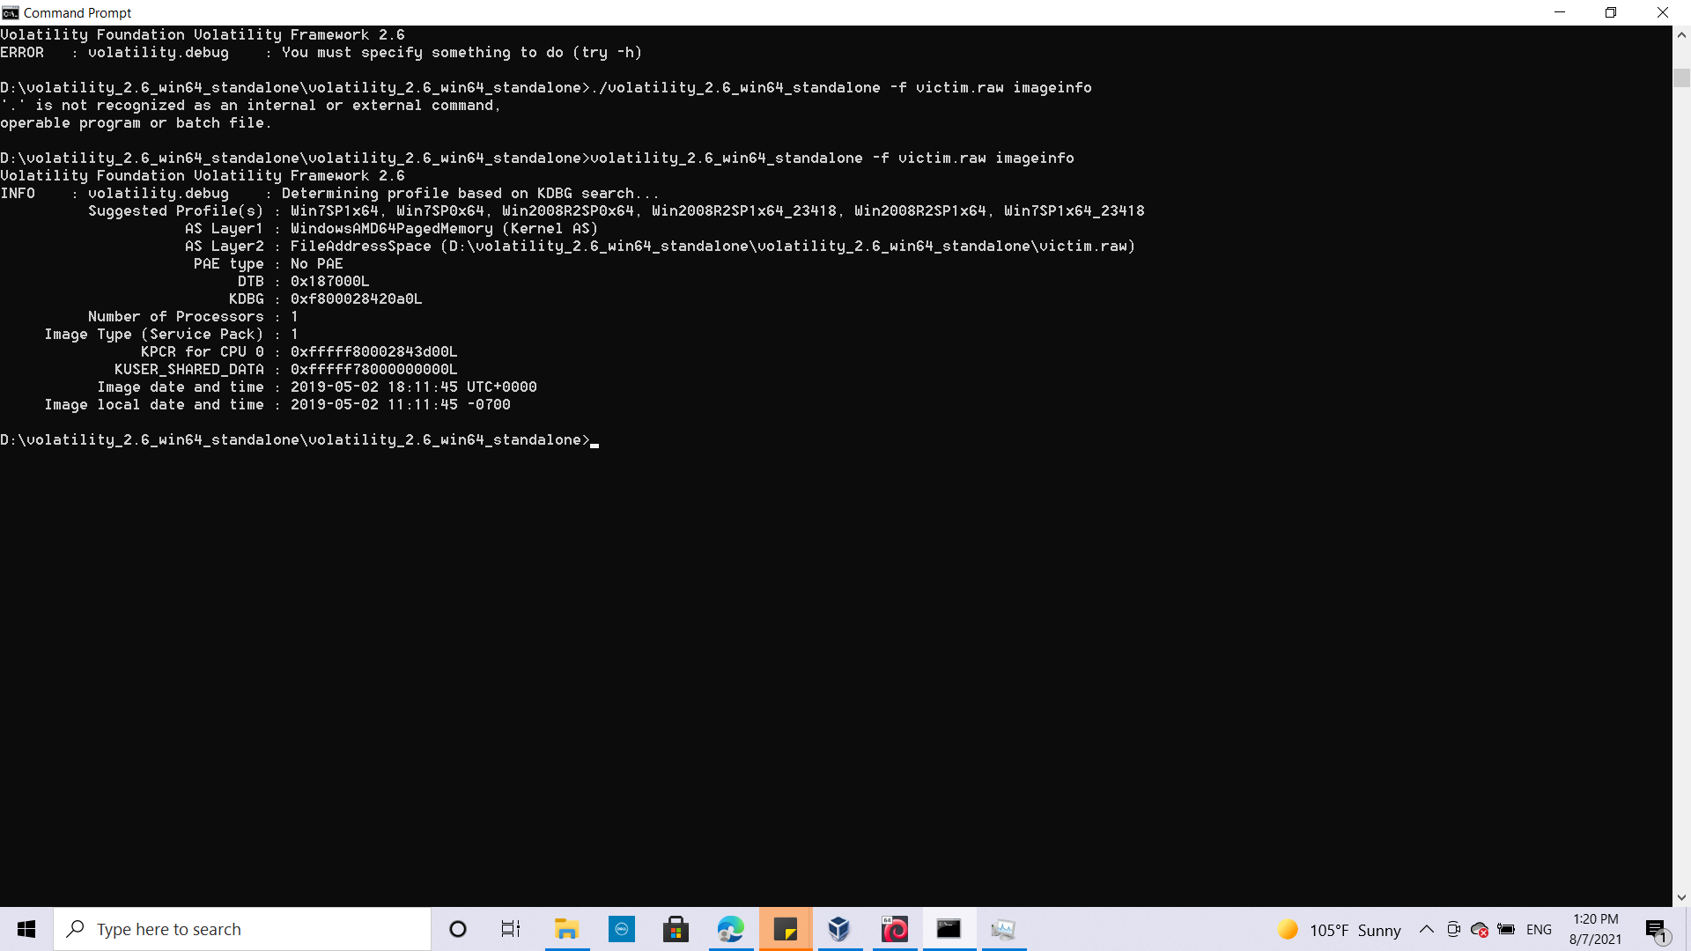

**Q3:** What is the PID of SearchIndexer? (answer : 2180)

Mentioning the system profile and by using **pslist** plugin to list out all the processes that were running at the time of image creation and it’s ID

*Command used :* volatility_2.6_win64_standalone -f victim.raw --profile=Win7SP1x64 pslist

Fin the Searchindexer unde the “Name” column which indicates the process name and find its corresponding process ID under “PID” column

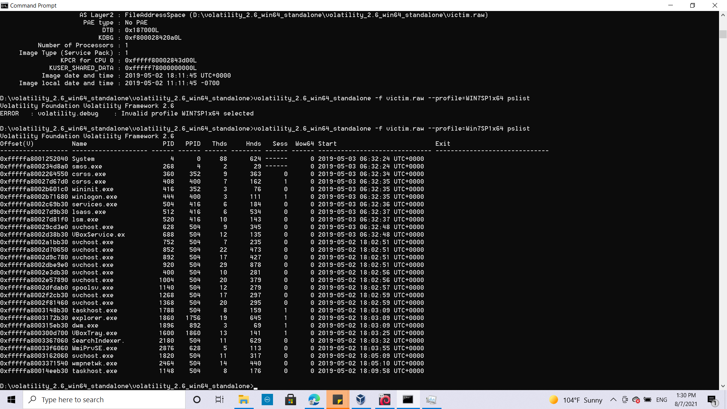

**Q4:** What is the last directory accessed by the user?

(The last folder name as it is?)

(answer: deleted_files)  
after checkig the hint : conclusion use shellbags plugin

By using shellbags plugin to gather all the information about a viewed directory such as size, position, and icon.  
  
***Comman used:*** volatility_2.6_win64_standalone -f victim.raw --profile=Win7SP1x64 shellbags

Check the access date and time and get the name of last directory accessed. The last date accessed found 2019-04-27 10:38:24 UTC+0000 , find the corresponding name (deleted_files)

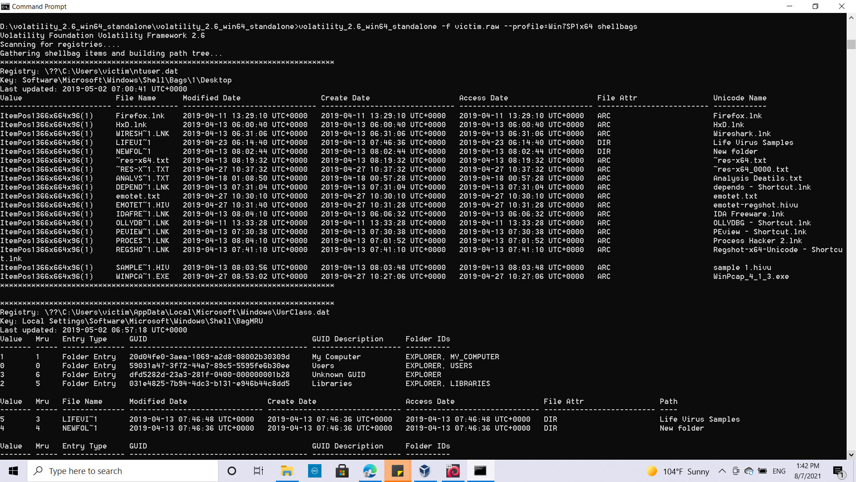

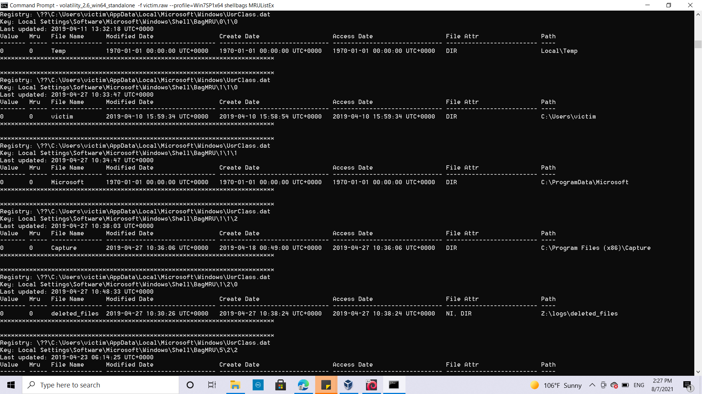

**Task 2 Exploring virtual address descriptor tag and netscan**

**Q1:** There are many suspicious open ports; which one is it? (ANSWER format: protocol:port)

(answer:UDP:5005)

By using netsvan plugin and the hint

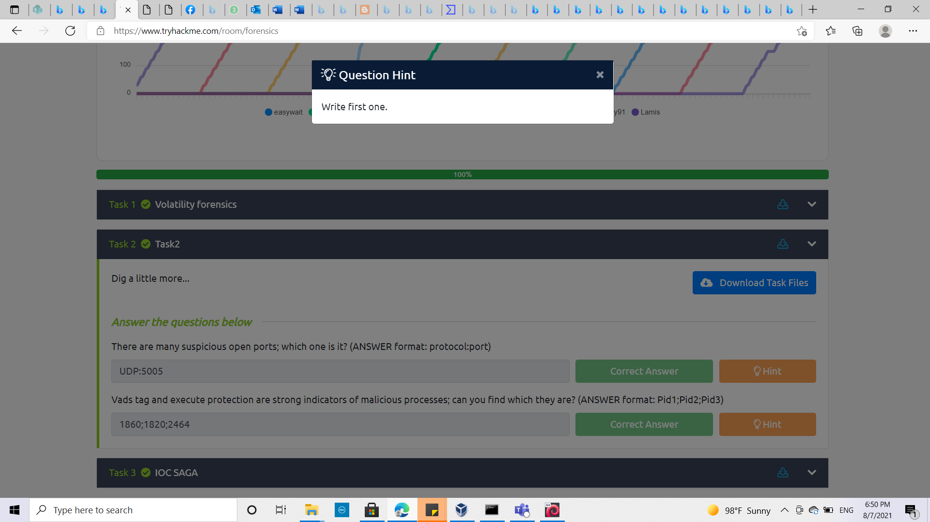

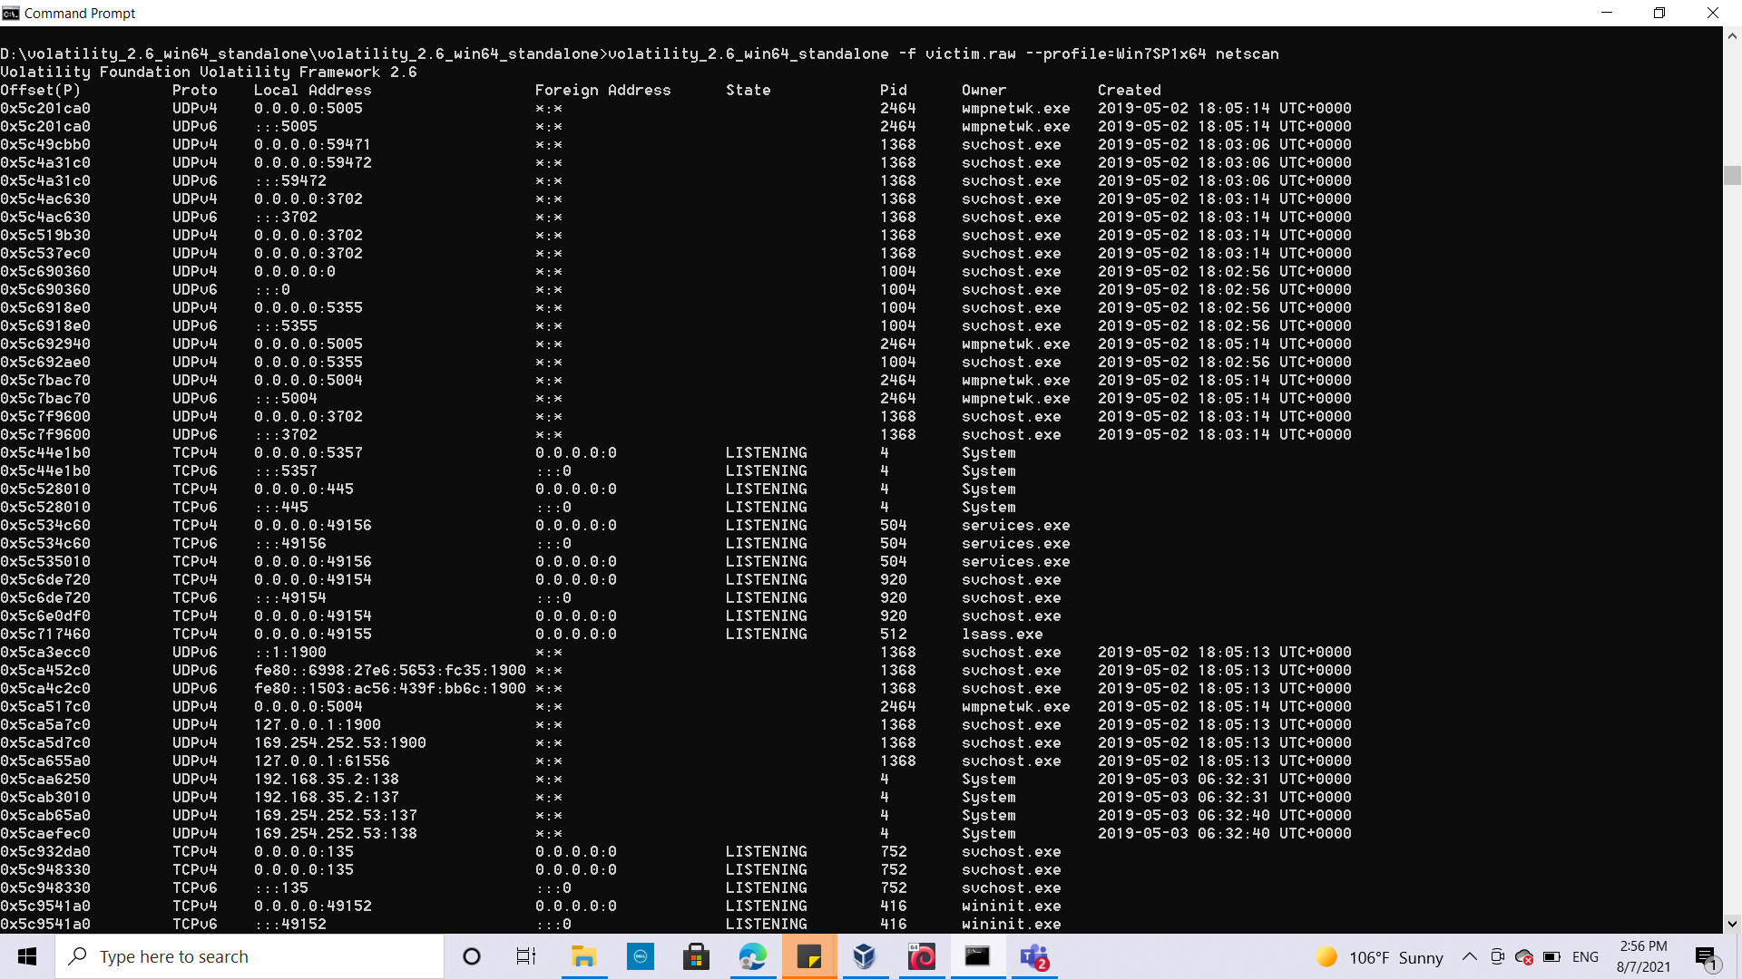

**Q2:**Vads tag and execute protection are strong indicators of malicious processes; can you find which they are? (ANSWER format: Pid1;Pid2;Pid3)  
(answer 1860;1820;2464)

By using the malfind plugin three processes that are malicious found out.

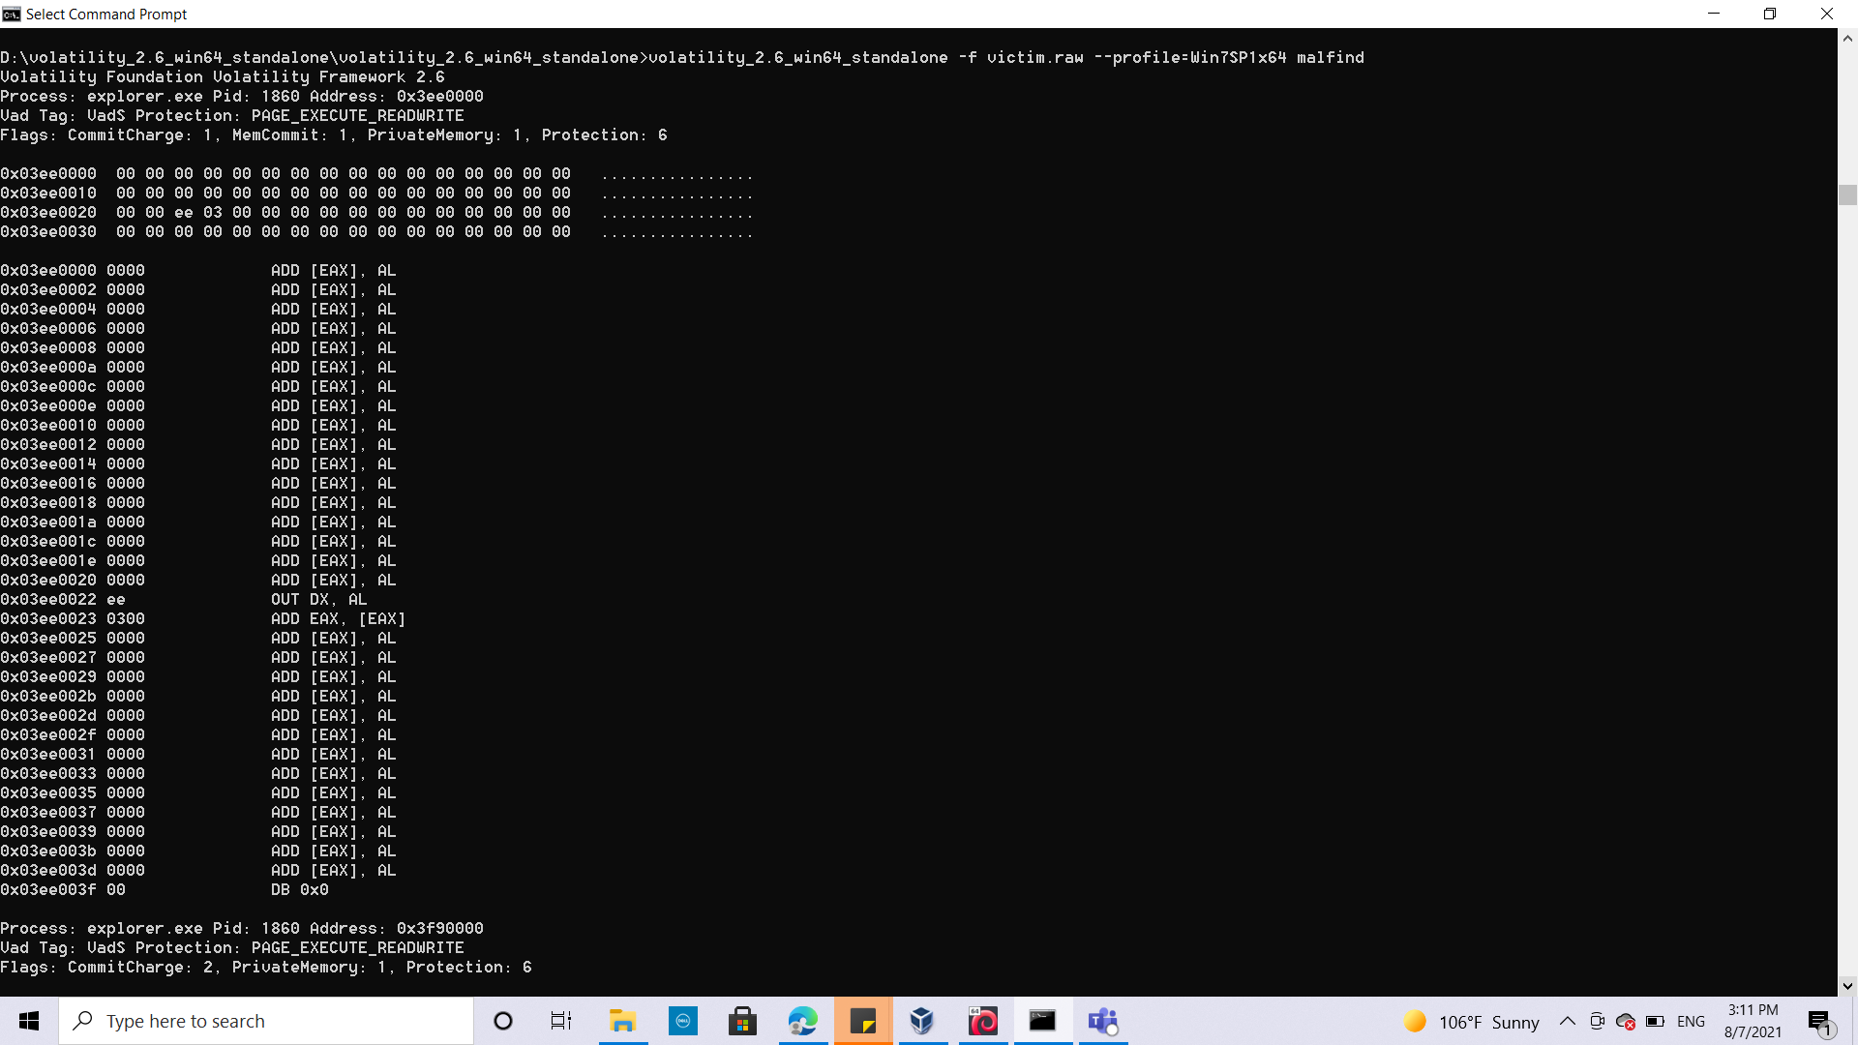

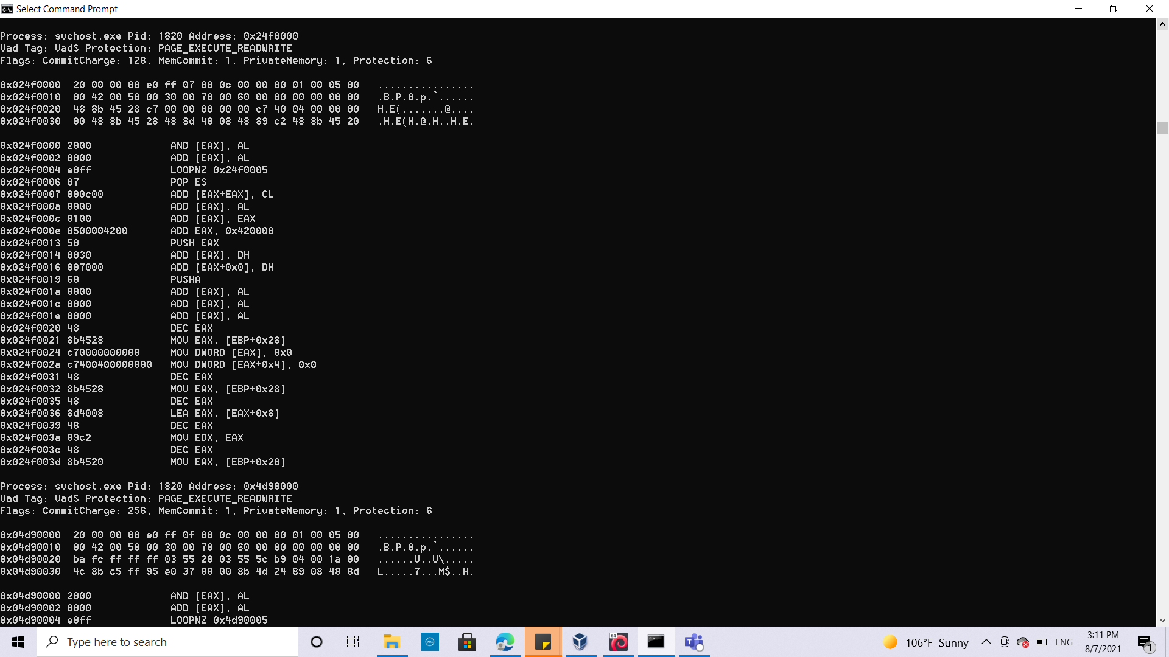

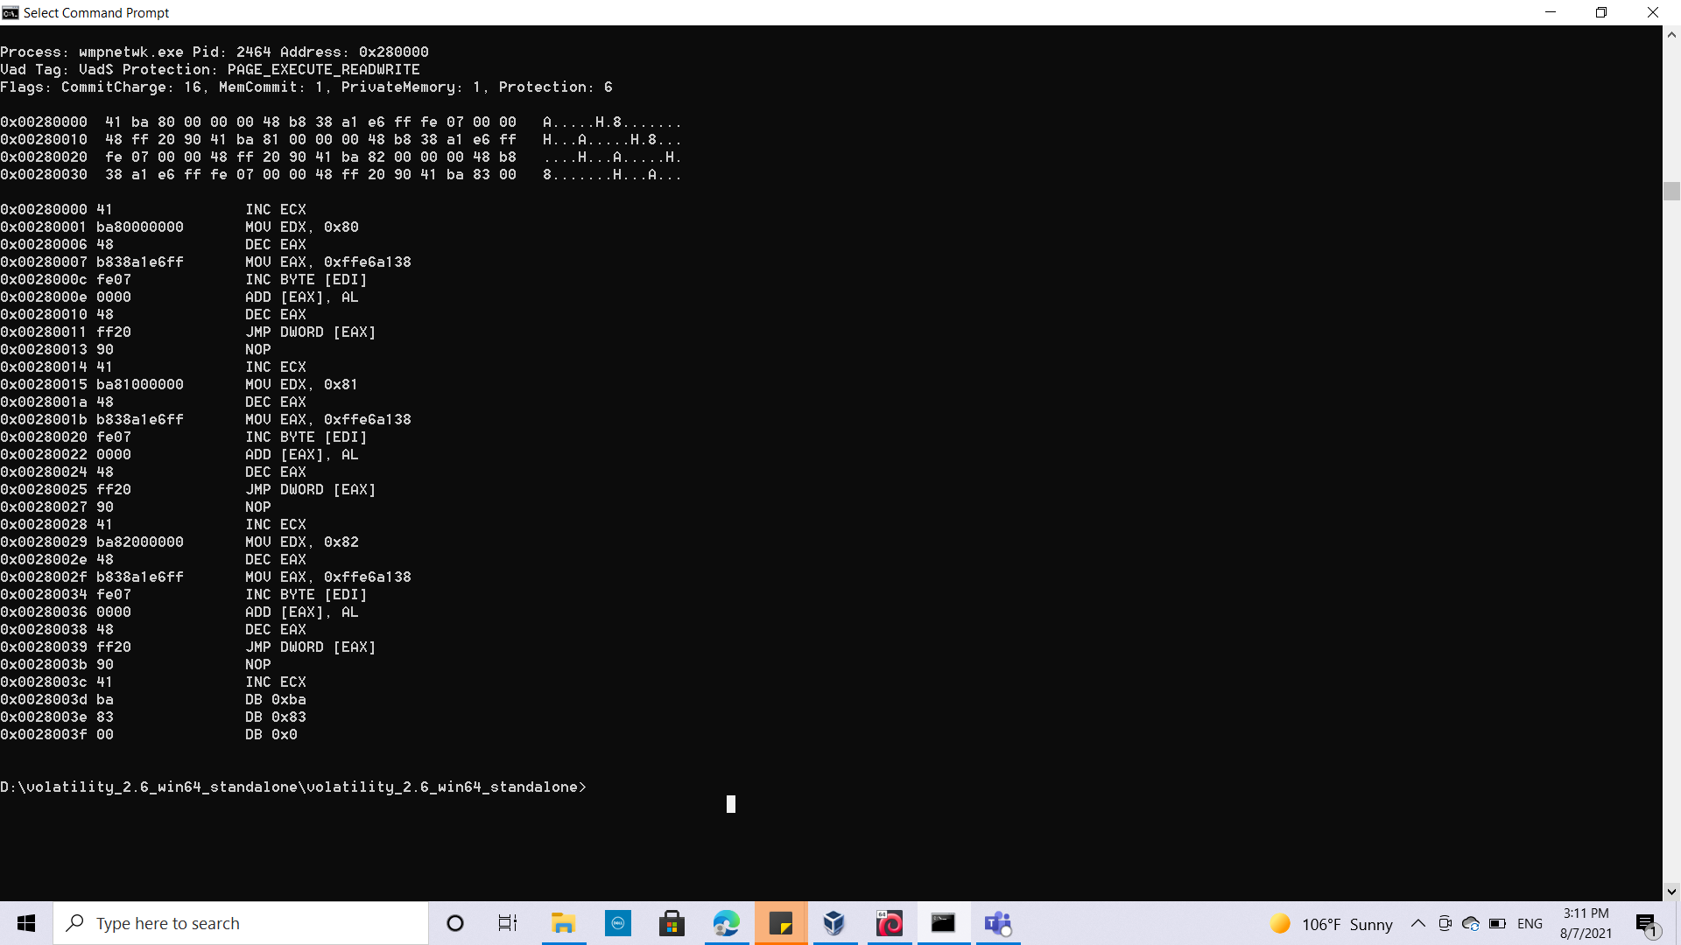

**Task 3 Finding Indicators Of Compromise SAGA**

***Note:I used windows cmd in all previous questions even dumping the memory of this task , and I copied the malicious dumps inside a kali for search and grep inside the dump and answer the below questions***

In the previous task, you identified malicious processes, so let's dig into them and find some Indicator of Compromise (IOC). You just need to find them and fill in the blanks (You may search for them on VirusTotal to discover more details).  
  
using the malicious Processes ID to dump the memory (by using memdump plugin) of these malicious processes and search for the below required

***Command used :*** volatility_2.6_win64_standalone -f victim.raw -p 1860,1820,2464 --profile=Win7SP1x64 memdump -D .

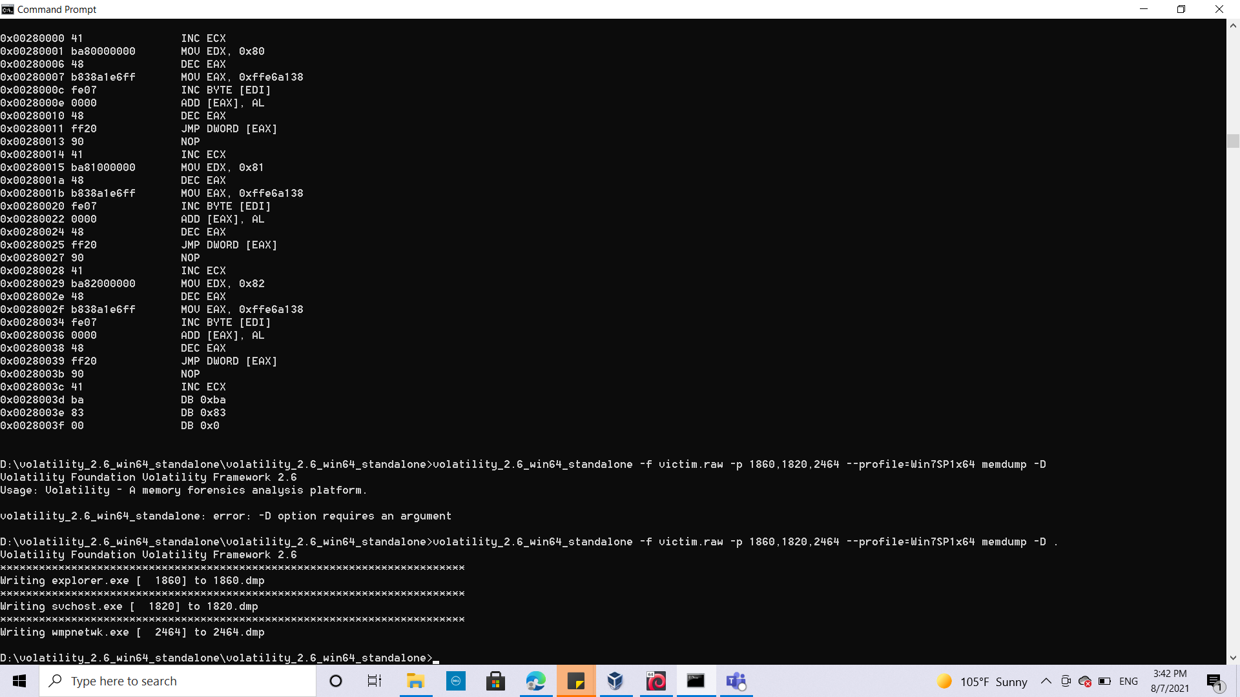

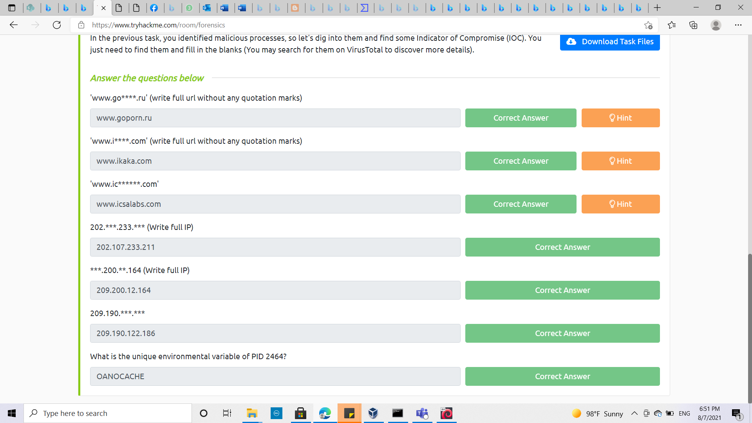

**Q1:** 'www.go****.ru' (write full url without any quotation marks)  
(answer: [www.goporn.ru](http://www.goporn.ru))

By using the hint below   
***Command used :*** strings 1820.dmp | grep ‘\<www\.go....\.ru\>’

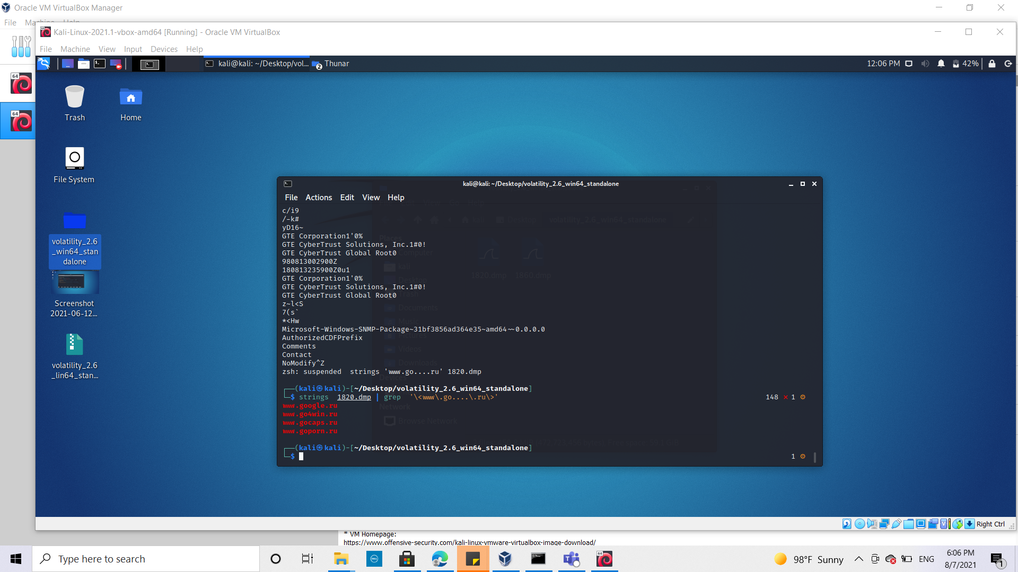

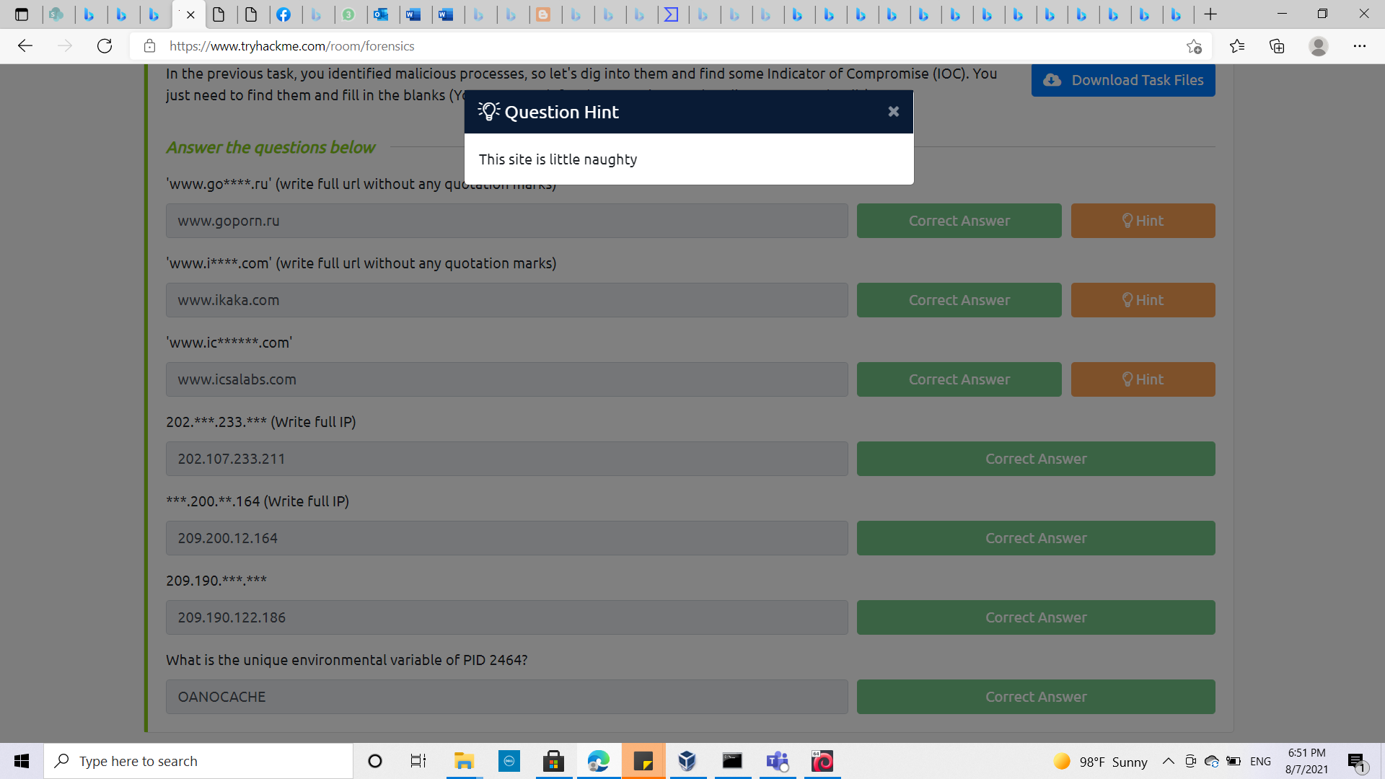

**Q2:** 'www.i****.com' (write full url without any quotation marks)  
(answer: www.ikaka.com)

By using the hint below   
***Command used :*** strings 1820.dmp | grep ‘\<www\.i....\.com\>’

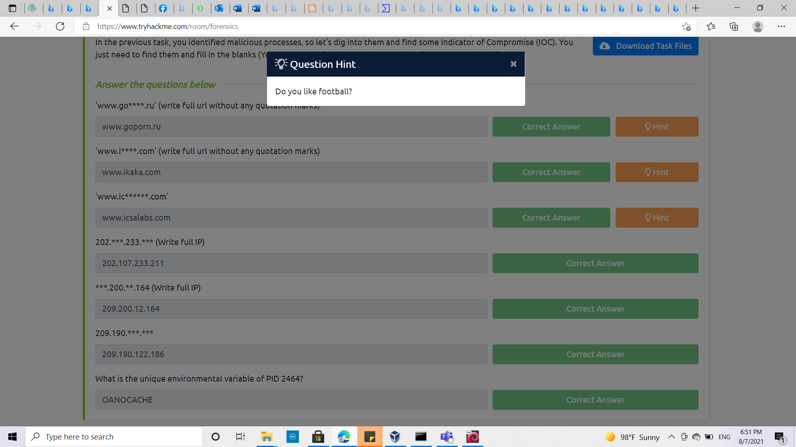

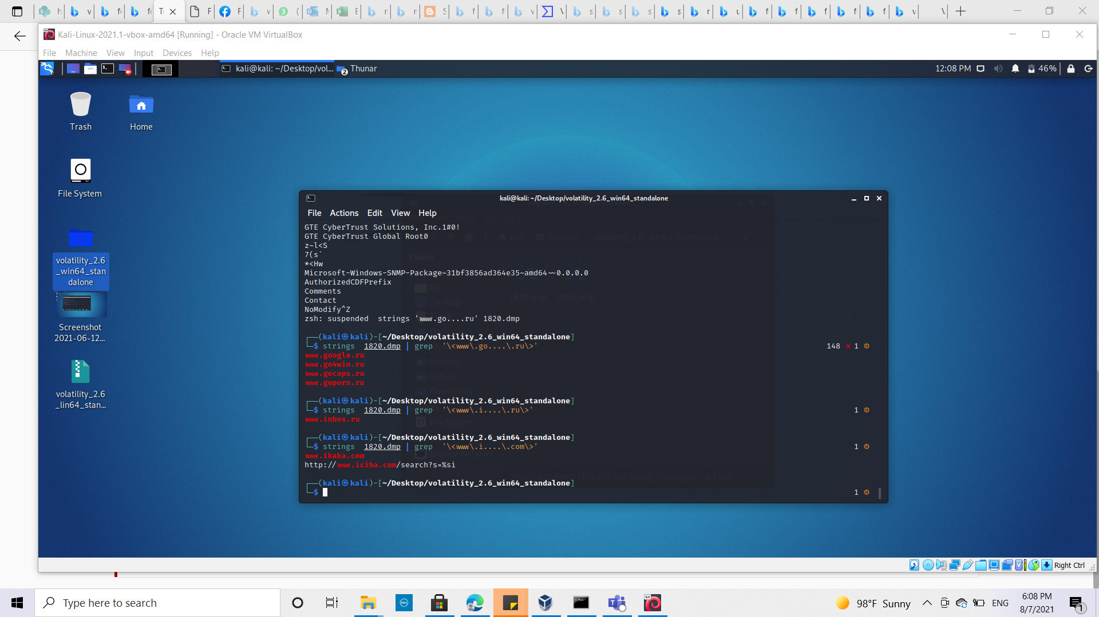

**Q3**:'www.ic******.com'   
(answer : www.icsalabs.com)

By using the hint below   
***Command used :*** strings 1820.dmp | grep ‘\<www\.ic......\.com\>’

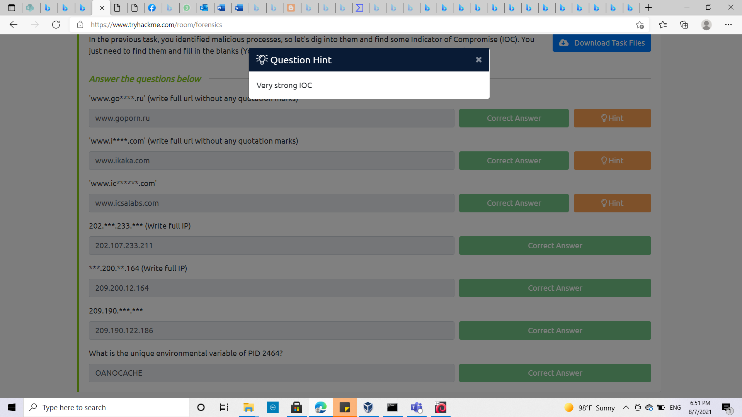

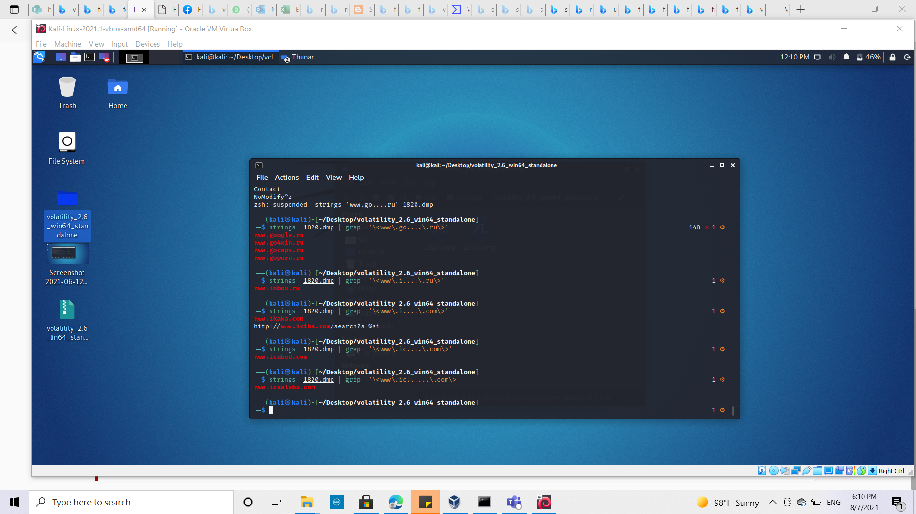

**Q4:** 202.***.233.*** (Write full IP)

***Command used :*** strings 1820.dmp | grep ‘\<202\....\.233\....>’  
(answer: 202.107.233.211)

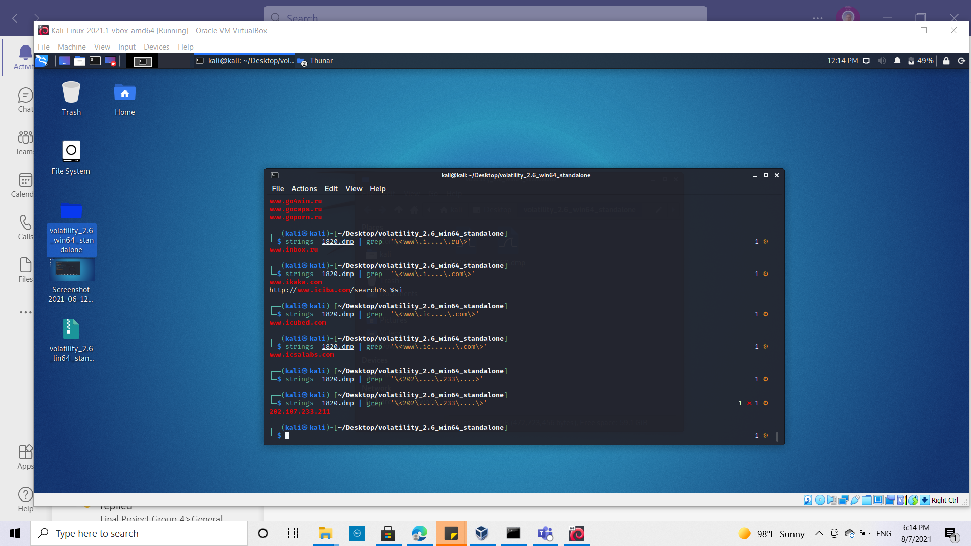

**Q5:** ***.200.***.164 (Write full IP)

***Command used :*** strings 1820.dmp | grep ‘\<...\.200\....\.164>’  
(answer: 209.200.12.164)

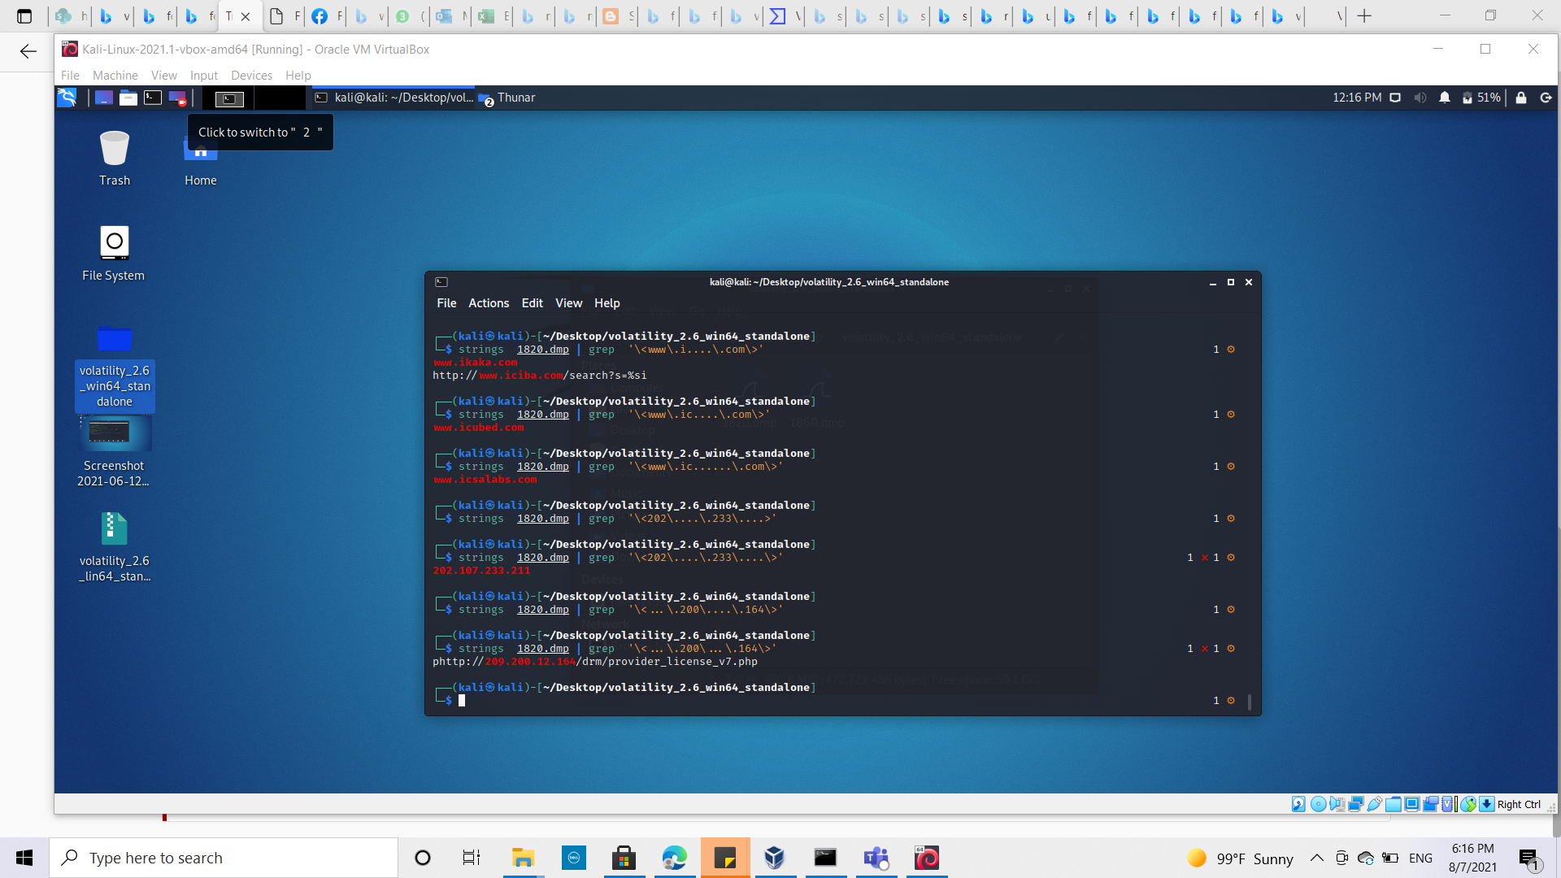

**Q6:** 209.190.***.*** (Write full IP)

***Command used :*** strings 1820.dmp | grep ‘\<209\.190\....\....>’  
(answer: 209.190.122.186)

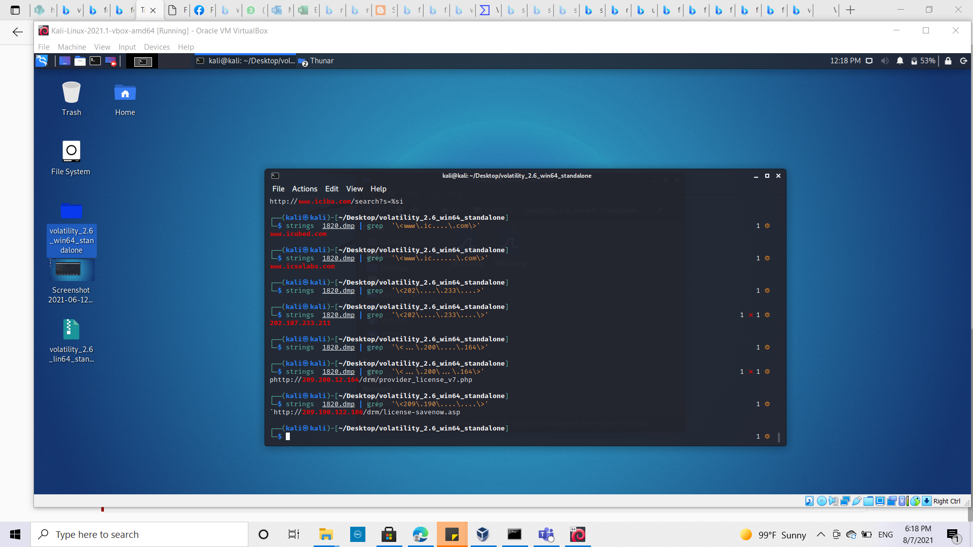

**Q7:** What is the unique environmental variable of PID 2464?  
(answer :OANOCACHE) as its not system variable

By using envars plugin to display the environmental variables

***Command used :*** volatility_2.6_win64_standalone -f victim.raw -p 2464 --profile=Win7SP1x64 envars

